**PROJECT REPORT**

Balemla Harika

**177r1a0564@gmail.com**

E-COMMERCE WEBSITE

This website contain vegatables,fruits,produtcs,subscription,contact tabs

In vegetables tab it contains the different vegetables price.

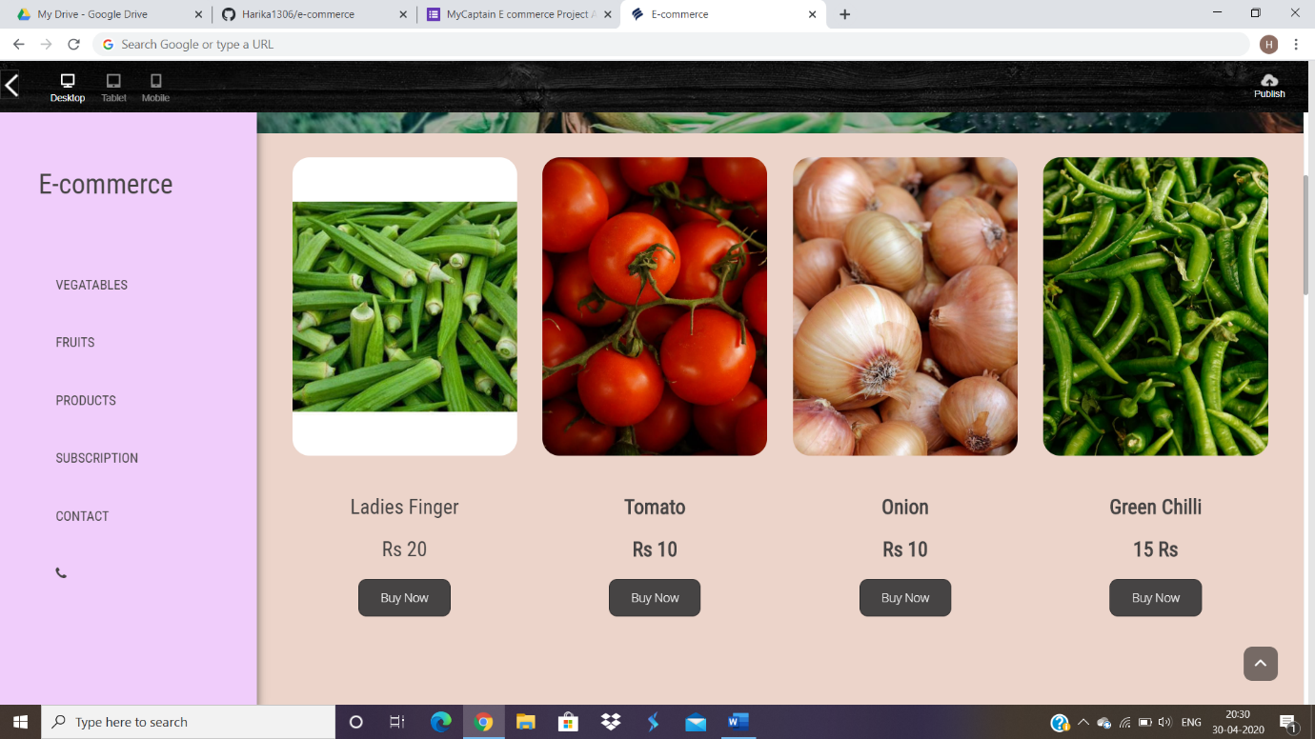

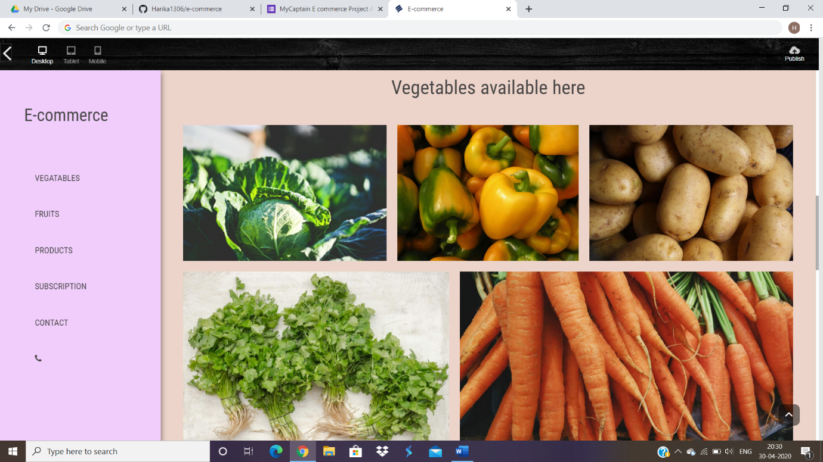

Fruits tab:

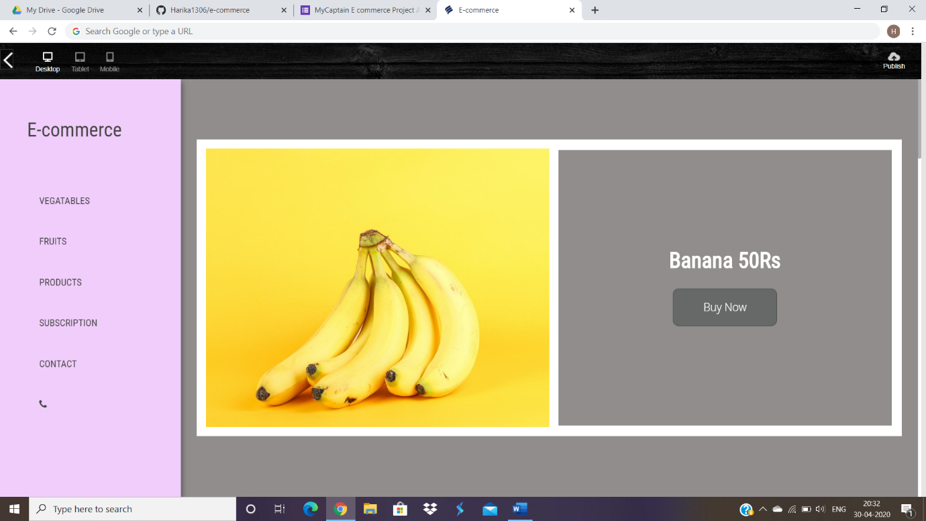

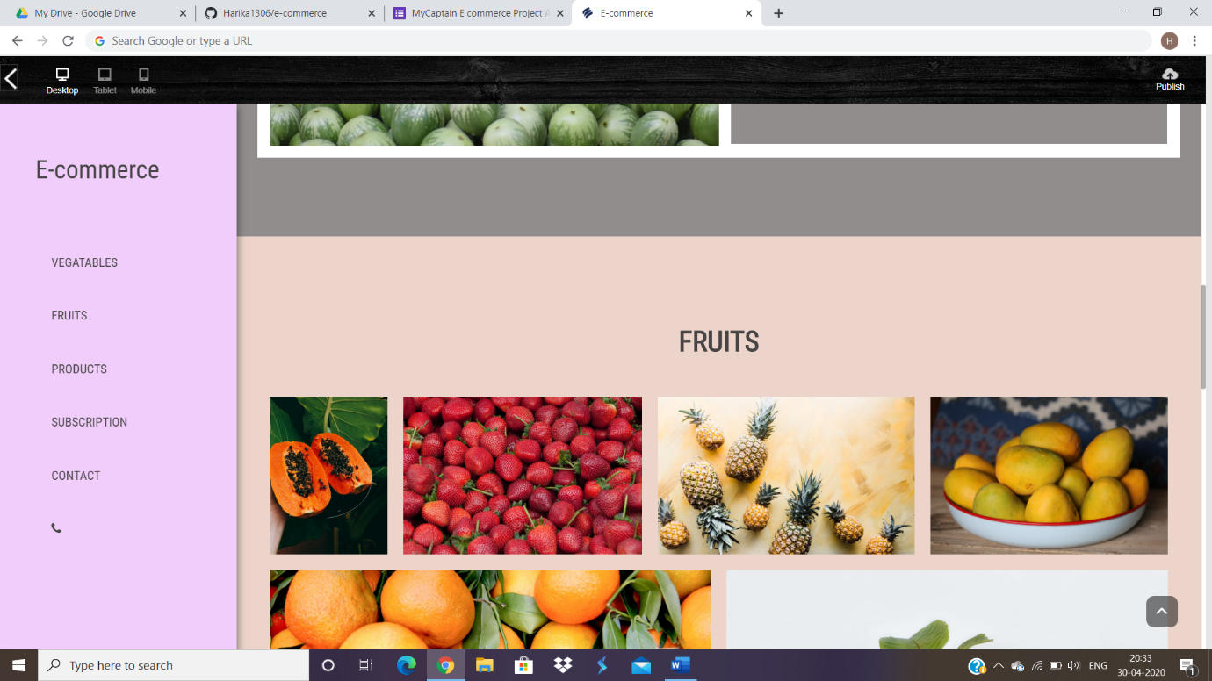

Product tab:

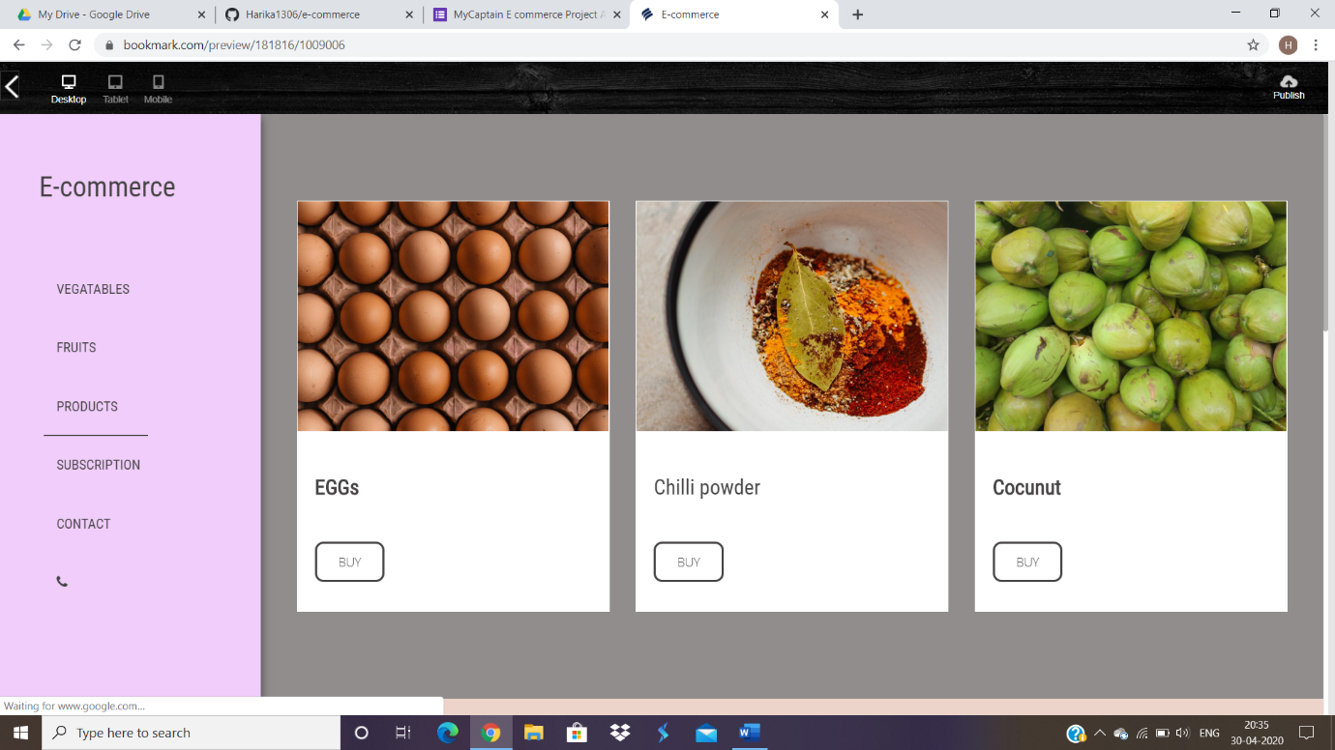

Subscription tab:

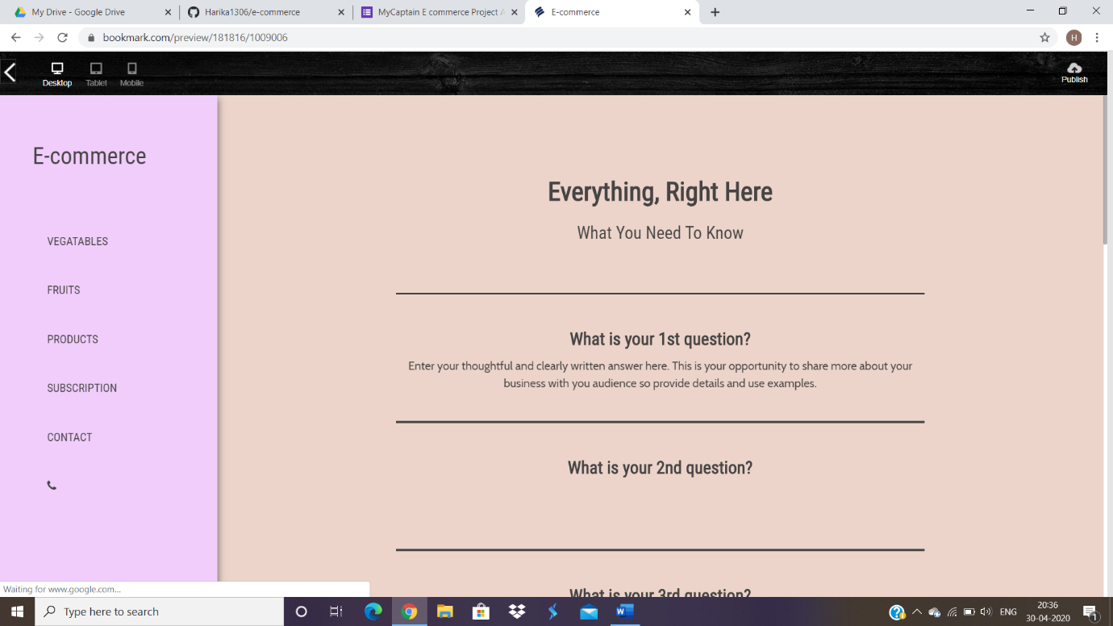

Contact tab:

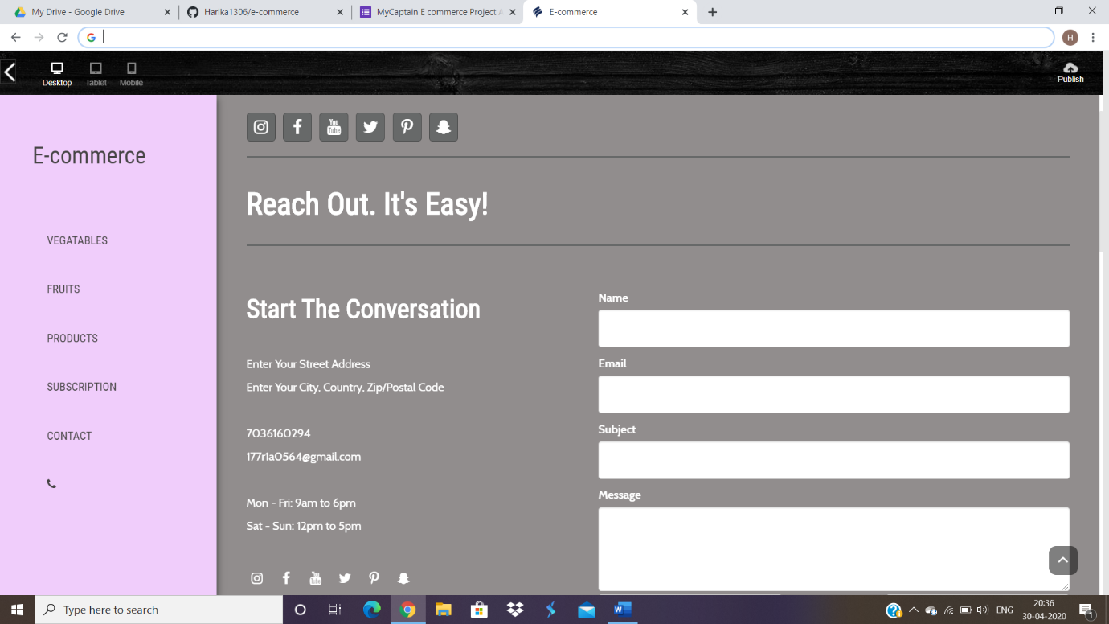

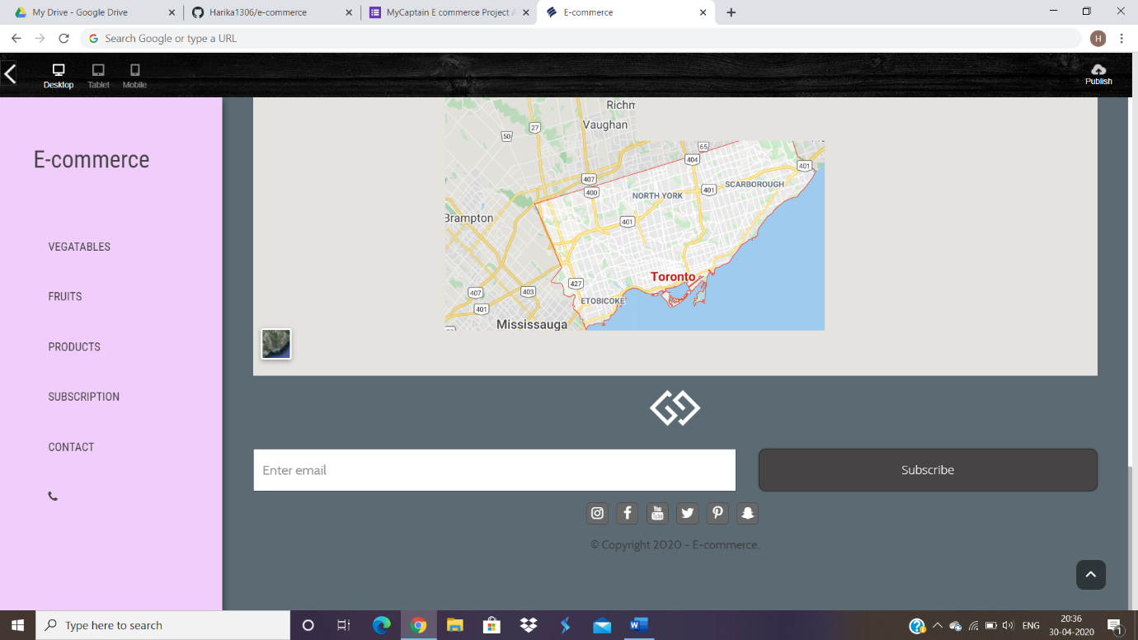

Phone:

